HOW TO SET STM32 BOARDS AS HOST IN FULL SPEED MODE
*Board used in this example : H723ZG-NUCLEO

Select your board
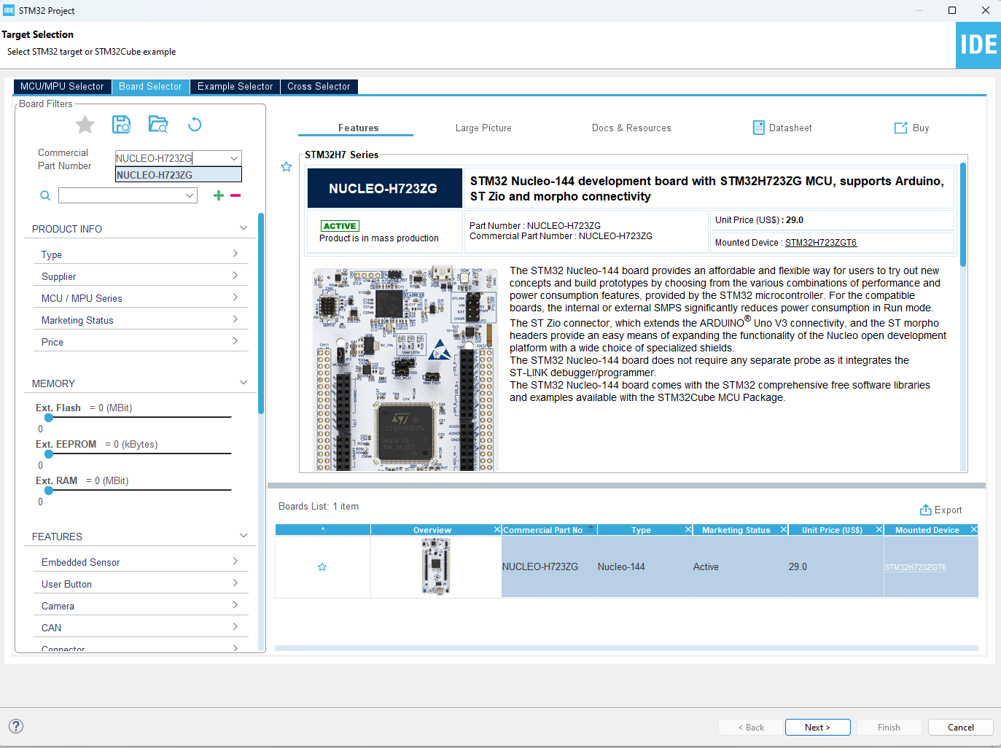
Name your project
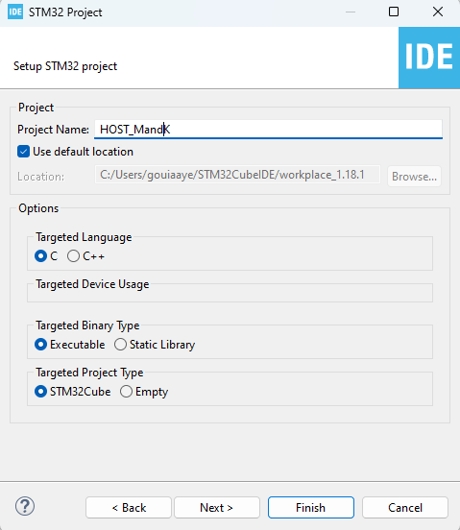
Clear your pinouts
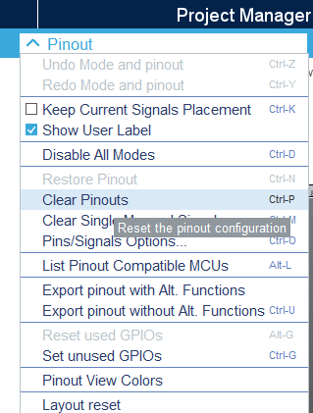
In RCC Choose your board convenient clock
*verify using specific document if your board support the selected clock for this task or not
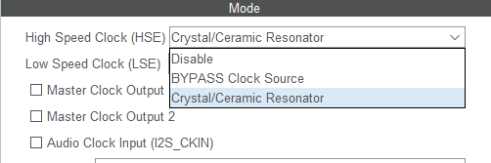
In connectivity choose Host_only In fullspeed PHY interface and enable USB global interrupt
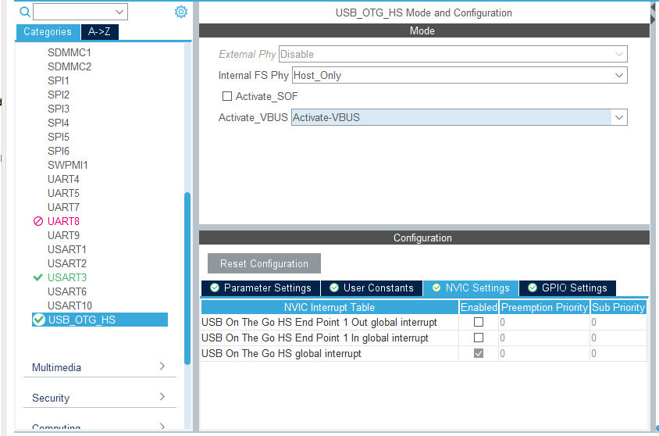
Enable your board specific usart that is linked to st link port
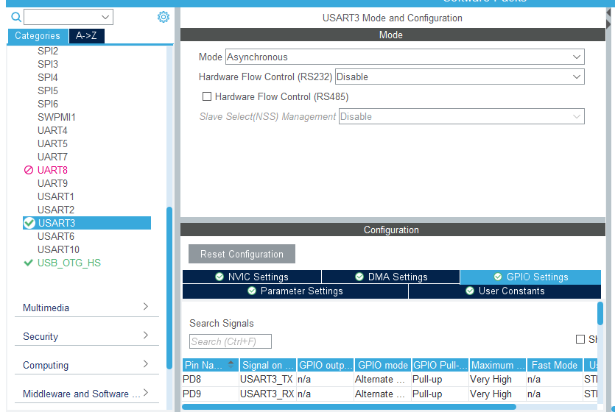
Verify in the schematics and other documents if needed the convenient usart to use

In H723 case using board schematic we can see here that stlink ports are named T_VCP_RX and T_VCP_TX
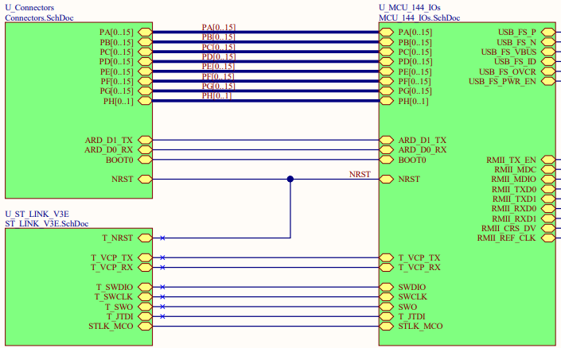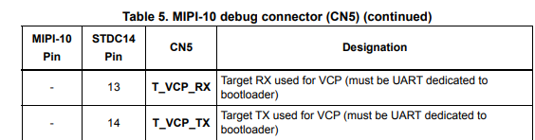
And here we can see that these pins are related to USART3 and exactly PD8 and PD9 pins
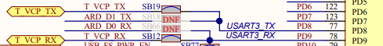

Search for your board specific Vbus supply in schematics and activate it as GPIO OUTPUT .In H723 example it is PD10 pin
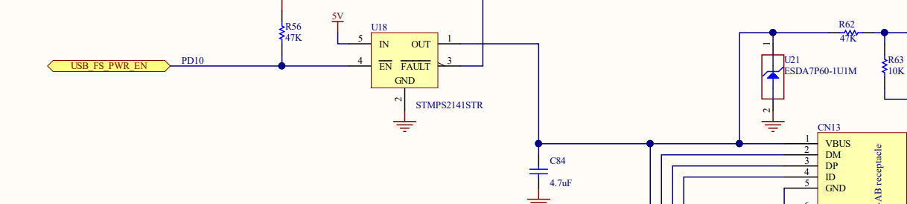
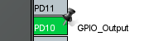
In middleware and software packs click USB_HOST and choose HID class then select GPIO_OUTPUT option in Drive_VBUS ans select your pin
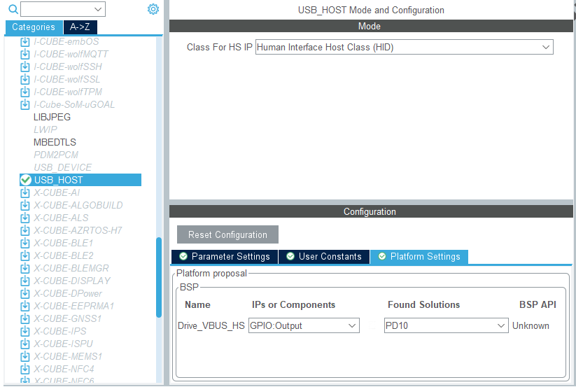
For clock configuration the clock
Select HSI48 for USB

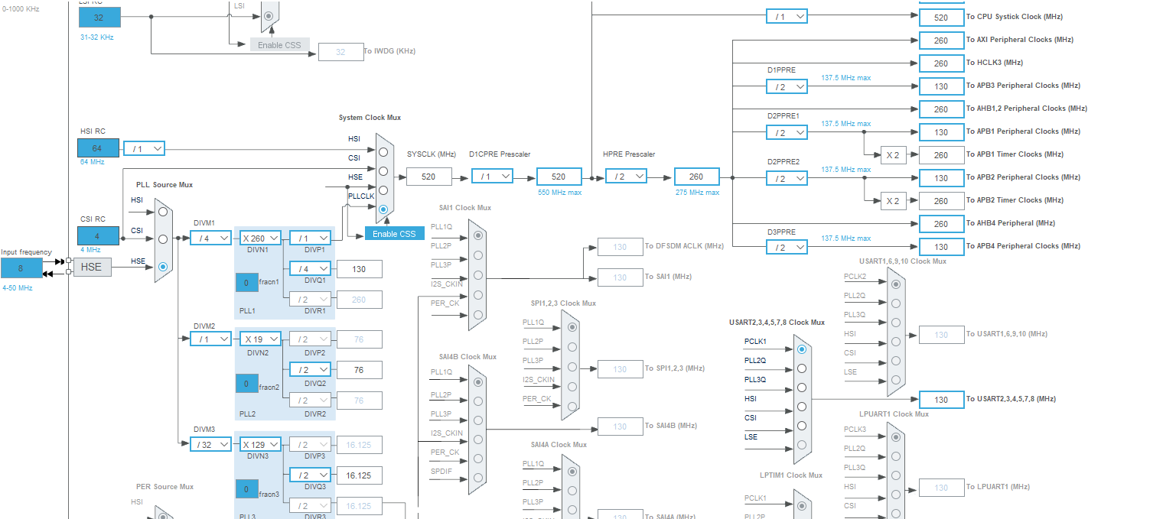
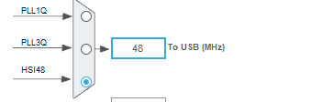

Generate your project
Now add these sections in each noted file
Main.c
void UART3_Log(const char *message)
{
HAL_UART_Transmit(&huart3, (uint8_t*)message, strlen(message), HAL_MAX_DELAY);
}

/* Initialize all configured peripherals */
SET_BIT (PWR->CR3, PWR_CR3_USB33DEN);

Host.c
/* Private variables ---------------------------------------------------------*/
__IO HID_APP_State hid_app_state;
extern HID_MOUSE_Info_TypeDef mouse_info;

/* USER CODE END PV */
extern UART_HandleTypeDef huart3;

void USBH_Clock_Config(void);
extern void HID_MOUSE_App(USBH_HandleTypeDef *phost);
extern void HID_KEYBRD_App(USBH_HandleTypeDef *phost);
static void HID_MOUSE_ProcessData(HID_MOUSE_Info_TypeDef *data);
void HID_KEYBRD_App(USBH_HandleTypeDef *phost);

extern void Error_Handler(void);
/* USER CODE END PFP */

void USBH_Clock_Config(void)
{
RCC_PeriphCLKInitTypeDef PeriphClkInitStruct = {0};
/* PLL3 for USB Clock */
PeriphClkInitStruct.PLL3.PLL3M = 8;
PeriphClkInitStruct.PLL3.PLL3N = 336;
PeriphClkInitStruct.PLL3.PLL3FRACN = 0;
PeriphClkInitStruct.PLL3.PLL3P = 2;
PeriphClkInitStruct.PLL3.PLL3R = 2;
PeriphClkInitStruct.PLL3.PLL3Q = 7;
PeriphClkInitStruct.PeriphClockSelection = RCC_PERIPHCLK_USB;
PeriphClkInitStruct.UsbClockSelection = RCC_USBCLKSOURCE_PLL3;
HAL_RCCEx_PeriphCLKConfig(&PeriphClkInitStruct);
}

void USBH_Clock_Config(void)
{
RCC_PeriphCLKInitTypeDef PeriphClkInitStruct = {0};
/* PLL3 for USB Clock */
PeriphClkInitStruct.PLL3.PLL3M = 8;
PeriphClkInitStruct.PLL3.PLL3N = 336;
PeriphClkInitStruct.PLL3.PLL3FRACN = 0;
PeriphClkInitStruct.PLL3.PLL3P = 2;
PeriphClkInitStruct.PLL3.PLL3R = 2;
PeriphClkInitStruct.PLL3.PLL3Q = 7;
PeriphClkInitStruct.PeriphClockSelection = RCC_PERIPHCLK_USB;
PeriphClkInitStruct.UsbClockSelection = RCC_USBCLKSOURCE_PLL3;
HAL_RCCEx_PeriphCLKConfig(&PeriphClkInitStruct);
}
void USBH_HID_AppProcess(void)
{
switch(hid_app_state)
{
case HID_APP_WAIT:
if(Appli_state == APPLICATION_READY)
{
if(USBH_HID_GetDeviceType(&hUsbHostHS) == HID_KEYBOARD)
{
hid_app_state = HID_APP_KEYBOARD;
UART3_Log("Use Keyboard to type characters:\r\n");
}
else if(USBH_HID_GetDeviceType(&hUsbHostHS) == HID_MOUSE)
{
hid_app_state = HID_APP_MOUSE;
UART3_Log("USB HID Host Mouse App...\r\n");
}
}
break;

case HID_APP_MOUSE:
if(Appli_state == APPLICATION_READY)
{
HID_MOUSE_App(&hUsbHostHS);
}
break;

case HID_APP_KEYBOARD:
if(Appli_state == APPLICATION_READY)
{
HID_KEYBRD_App(&hUsbHostHS);
}
break;

default:
break;
}

if(Appli_state == APPLICATION_DISCONNECT)
{
Appli_state = APPLICATION_IDLE;
UART3_Log("USB device disconnected !!!\r\n");
hid_app_state = HID_APP_WAIT;
}
}

/**
* @brief Main routine for Mouse application
* @param phost: Host handle
* @retval None
*/

/* USER CODE END 1 */
static void HID_MOUSE_ProcessData(HID_MOUSE_Info_TypeDef *data)
{
char buffer[50];
if((data->x != 0) || (data->y != 0))
{
snprintf(buffer, sizeof(buffer), "Mouse : X = %3d, Y = %3d\r\n", data->x, data->y);
UART3_Log(buffer);
}
}
void HID_KEYBRD_App(USBH_HandleTypeDef *phost)
{
HID_KEYBD_Info_TypeDef *k_pinfo;
char c;
k_pinfo = USBH_HID_GetKeybdInfo(phost);
if(k_pinfo != NULL)
{
c = USBH_HID_GetASCIICode(k_pinfo);
if(c != 0)
{
char buffer[2] = {c, '\0'};
UART3_Log(buffer);
}
}
}
void HID_MOUSE_App(USBH_HandleTypeDef *phost)
{
HID_MOUSE_Info_TypeDef *m_pinfo;

m_pinfo = USBH_HID_GetMouseInfo(phost);

if(m_pinfo != NULL)
{
/* Handle Mouse data position */
HID_MOUSE_ProcessData(&mouse_info);

if(m_pinfo->buttons[0])
{
UART3_Log("Left Button Pressed\r\n");
}
if(m_pinfo->buttons[1])
{
UART3_Log("Right Button Pressed\r\n");
}
if(m_pinfo->buttons[2])
{
UART3_Log("Middle Button Pressed\r\n");
}
}
}

Main.h
/* USER CODE BEGIN INCLUDE */
#include "usbh_hid.h"
#include "usbh_hid_parser.h"
/* USER CODE END INCLUDE */

/** USER CODE BEGIN1 **/
typedef enum {
HID_APP_IDLE = 0,
HID_APP_WAIT,
HID_APP_MOUSE,
HID_APP_KEYBOARD,
}HID_APP_State;
/** USER CODE END1 **/
void USBH_HID_AppProcess(void);

Now just build and run your project
If you encounter any problem in building your project or something unclear in one of the section you need to add . a project with this function will be attached with this guide.

Open your serial monitor tool (ex : tera term)
Attach a keyboard or mouse via a (micro type b female type a cable)
Configure the necessary settings
